# Obsequy Project Setup Steps

1. Install Mongo DB:

<http://www.mongodb.org/dr/downloads.mongodb.org/win32/mongodb-win32-x86_64-2.4.4.zip/download>

1. Instructions:

<http://docs.mongodb.org/manual/tutorial/install-mongodb-on-windows/>

1. Install Mongo Vue:

<http://www.mongovue.com/downloads/>

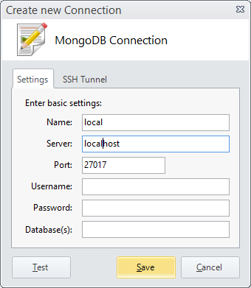

1. Create SQL DB called **Obsequy**
2. Run script:

**Generate DB Tables.sql**

1. In project create connection string:

<!-- Ed's Connection Strings -->

<add name="DefaultConnection" connectionString="Data Source=EDD-PC\SQLEXPRESS;Initial Catalog=Obsequy;Integrated Security=True;MultipleActiveResultSets=True;Application Name=EntityFramework" providerName="System.Data.SqlClient" />

Create the Visual Studio ASP.NET MVC 4 Web Application project:

* Select the Durandal SPA Project template.
* Rename the web project: Obsequy.Web.
* Close VS and rename the folder Obsequy.Web.
* Reopen the solution, and reload Obsequy.Web.
* Rename namespaces in Obsequy.Web project from *Obsequy* to *Obsequy.Web*.
* Create a Lib folder in the solution

Add the following projects to the Lib folder:

* **Obsequy.Communication**
* **Obsequy.Data**
* **Obsequy.Data.Contracts**
* **Obsequy.Model**
* **Obsequy.Utility**

Add the following NuGet Packages (JavaScript packages to Obsequy.Web only)

* Amplify.js
* Bootstrap LESS Source (web project)
* FluentValidation
* Google Maps Web Services API wrapper for .NET
* Modernizr.js
* Moment.js
* Ninject
* NLog
* SendGrid
* Twilio
* Toastr.js
* Underscore.js
* Windows Azure Configuration Manager
* Dotless
* JqueryUI.js
* Official MongoDB C# driver
* FluentMongo
* MongoRepository
* MongoDB.Web
* Spin.js
* Microsoft ASP.NET Web Pages 2 Web Data
* Microsoft ASP.NET SignalR JavaScript Client (Web project only)
* Microsoft ASP.NET SignalR System.Web.Components (Communications project)
* Microsoft ASP.NET SignalR Core Components (Communications project)
* Microsoft ASP.NET SignalR OWIN (Communications project)
* Microsoft ASP.NET SignalR Service Bus Messaging Backplane(Communications project)